Jeremy Rios-Martinez

Comsc 265

Assignment 15-16

int Length(char \*s);



char \*FindChar(char \*s, char c);

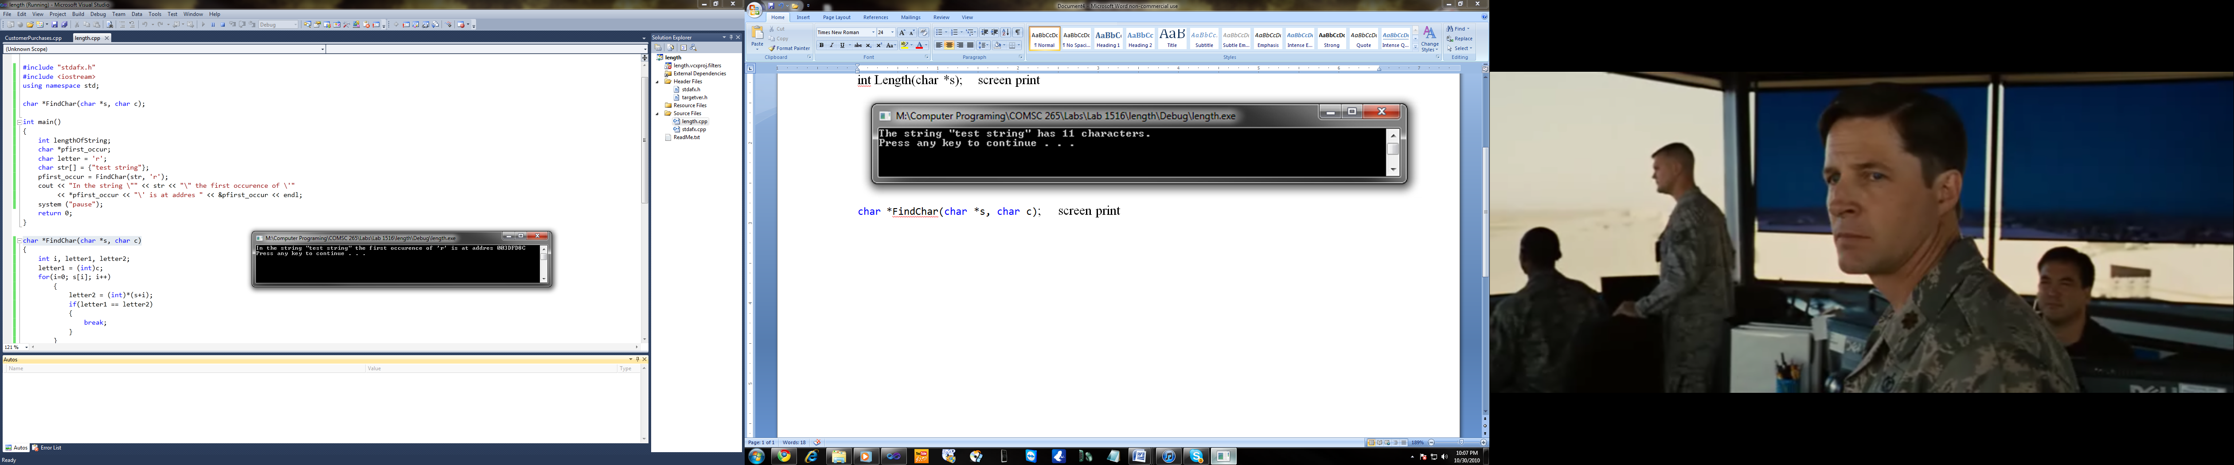

int Compare(char \*s1, char \*s2);

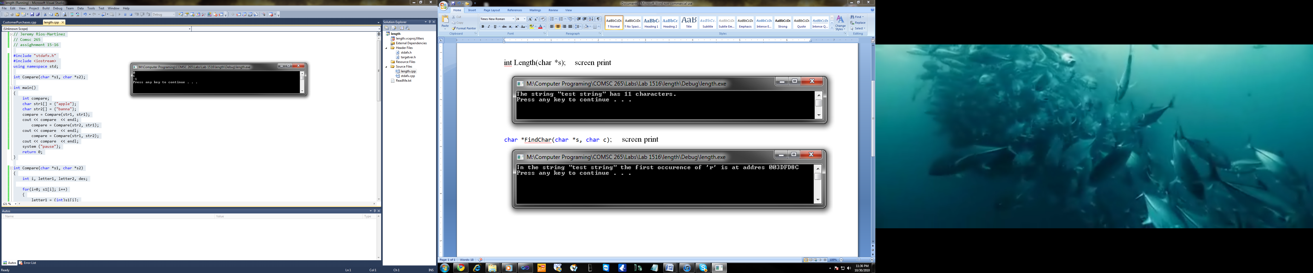

char \*Copy(char \*s1, char \*s2);

